**The Company Held the Compliance Training Seminar in Zambia**

The Company Secretary and Chief Compliance Officer Hu Aibin chaired a compliance training seminar in Zambia on April 19. A total of 22 personnel, including the person in charge of compliance of the enterprises in Zambia and Democratic Republic of the Congo, the General Counsel, CFO and the Financial Manager, attended the meeting.

The meeting was held at the conference room of NFCA Southeast Orebody Central Office. At first, Hu Aibin expressed his heartfelt thanks for the hardworking that all colleagues attending the conference have made for the compliance management in the past year and the achievements obtained on behalf of the Board of Directors and the Chairman of the Compliance Committee Tao Xinghu as well as the Executive Director and President Zhang Lin. Later on, he made special training and presentations for the Company's compliance management system, key and difficult points as well as the working orientation of next step. Then, the personnel in charge of the compliance of different enterprises, the General Counsel, CFO and the Financial Manager exchanged views on and made speeches on compliance management. Finally, Mr Zhou Liang, the Deputy General Manager and the General Counsel of the enterprise introduced the train of thought, progress and achievements of digitalized mine construction of Chambishi Copper Mine. After the meeting, Mr Zhou Liang guided the participants to visit the construction site of the southeast orebody construction.

Zhou Liang, the Deputy General Manager of NFCA, Li Chengguo, the CFO, Han Zhibin, the Manager of Financial Department, Gong Limao and Pan Hongjun, the head of General Affairs Department, Yang Peng, the Engineer of the Infrastructure Office and Ma Ruiwen, the Secretary in charge of Personnel Department; Wang Jingjun, the Executive Vice President of CLM, Zhou Zuotai, the Secretary of the Board of Directors, and Liu Yong, the principal of General Affairs Department; Qu Gang, the CFO of Chambishi Smelting, Xu Laixiang, the Deputy General Manager, Qiao Bo, the head of General Affairs Department and Liu Fang, the Director of the General Affairs Department; Zhang Hongyan, the CFO of SML, Weng Limin, the Director of the General Affairs Department, and Liu Yongqiang, the Director of the Legal Compliance Department; Lin Qujian, the Deputy General Manager and the General Counsel of CNMHH, and Zhu Dan, the Director of Legal Compliance Department; Zhou Linghui, the Deputy General Manager of Kambove as well as Wu Wenjun, the Deputy General Manager of Economic and Trade Cooperation Zone and others attended the meeting.

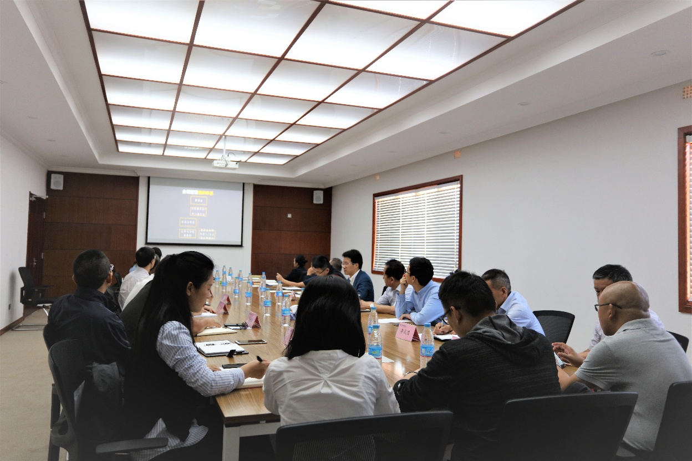

Compliance Exchange and Training Scenario

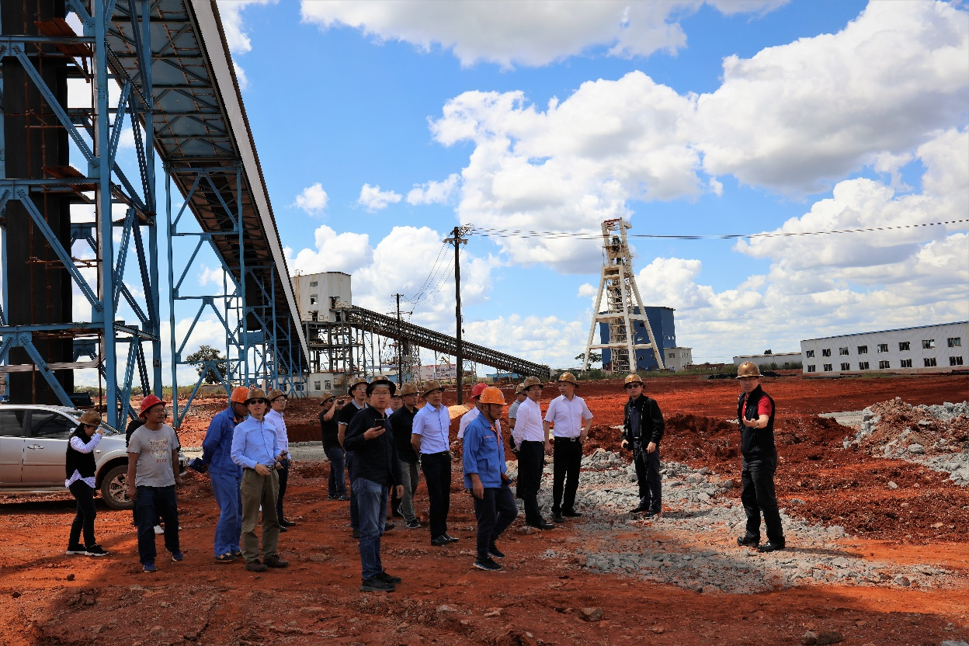SScenario for Visiting Southeast Orebody Construction

(Written by: NFCA Pan Hongjun)